Rough draft

From Current Production, if you edit a scope that is already included in another scenario, the following alert appears:

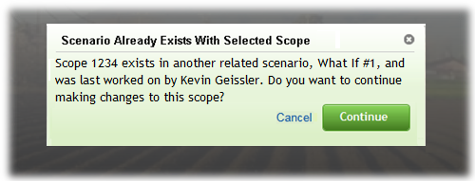

* Select “Cancel” to return to Current Production
* Select “Continue” to Create New Scenario
  + In what cases, if any, should scopes be grayed out? If changes were accidentally made to a scenario from Current Production, and we gray out the other scope(s), the scope they ACTUALLY want to be working on is grayed out. This could be confusing.
* The “Scenario Already Exists with Selected Scope” alert will only appear the first time that scope is edited. After the new scenario is created, you can edit that scope and not receive any additional alerts.
  + The alert **WILL** appear again in your new scenario if a 3rd scope is edited.

---

If you attempt to submit a scenario that someone else (April Beston) has made changes to, you will receive the following alert:

* **“During the submit process, the following scope(s) will be cancelled: Scope 1234. (April Beston)”**
  + **“Fix”** will prevent the scenario from being submitted.
  + **“Continue”** will submit the scenario. April could not submit any changes until after the nightly cycle. You are then notified who’s scenarios can no longer be submited.

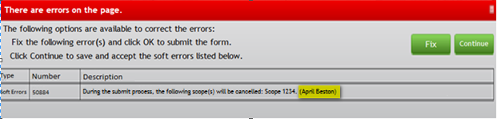

---

If April goes to submit afterwards, she would receive the following **HARD ERROR**:

* **“A related scenario, What If #1, has already been submitted by Kevin Geissler with these scopes in common: Scope 1234. This scenario cannot be submitted.”**
  + April is then sent back into Current Production. This is consistent with out the app currently works.

If you select “Fix”, you can go back and Undo Changes on individual objects and/or an entire scope.

* + If we have an “Undo Changes” option, I imagine we would have to have “Redo Changes”, as well. Losing all of your work from accidentally undoing changes wouldn’t be good!
  + We still should discuss where to include the button to undo changes for an entire scope?

